Github URL: <https://github.com/cpr016/COS420-Assignment1>

Important Notes:

1 – I believe that my github repository is private. I set it up as private, and it says private when hovering over it. If for some reason is it not, please let me know, because I don’t want to lose 30% of my grade because of it.

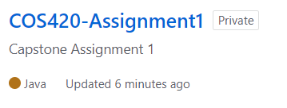

2 – Tests. I did not use any of the tests, as I believe you said we were allowed to do. And since all of them were very integrated into the example files, and we might use them later, I left them in the repository. However, this means specific launch parameters are needed for it to compile.

3 - Launch Parameters. Because of the tests, I had special launch parameters:

“mvn path” clean install -DskipTests -Dmaven.test.skip=true -f “pom.xml path”

My project compiles and launches perfectly fine with these arguments. If there is any issue, please let me know.